Reference Making a 3 D Object from a 2 D Image

<https://www.youtube.com/watch?v=VMqlsnMscsM>

Turn a cube to a vertex to start tracing

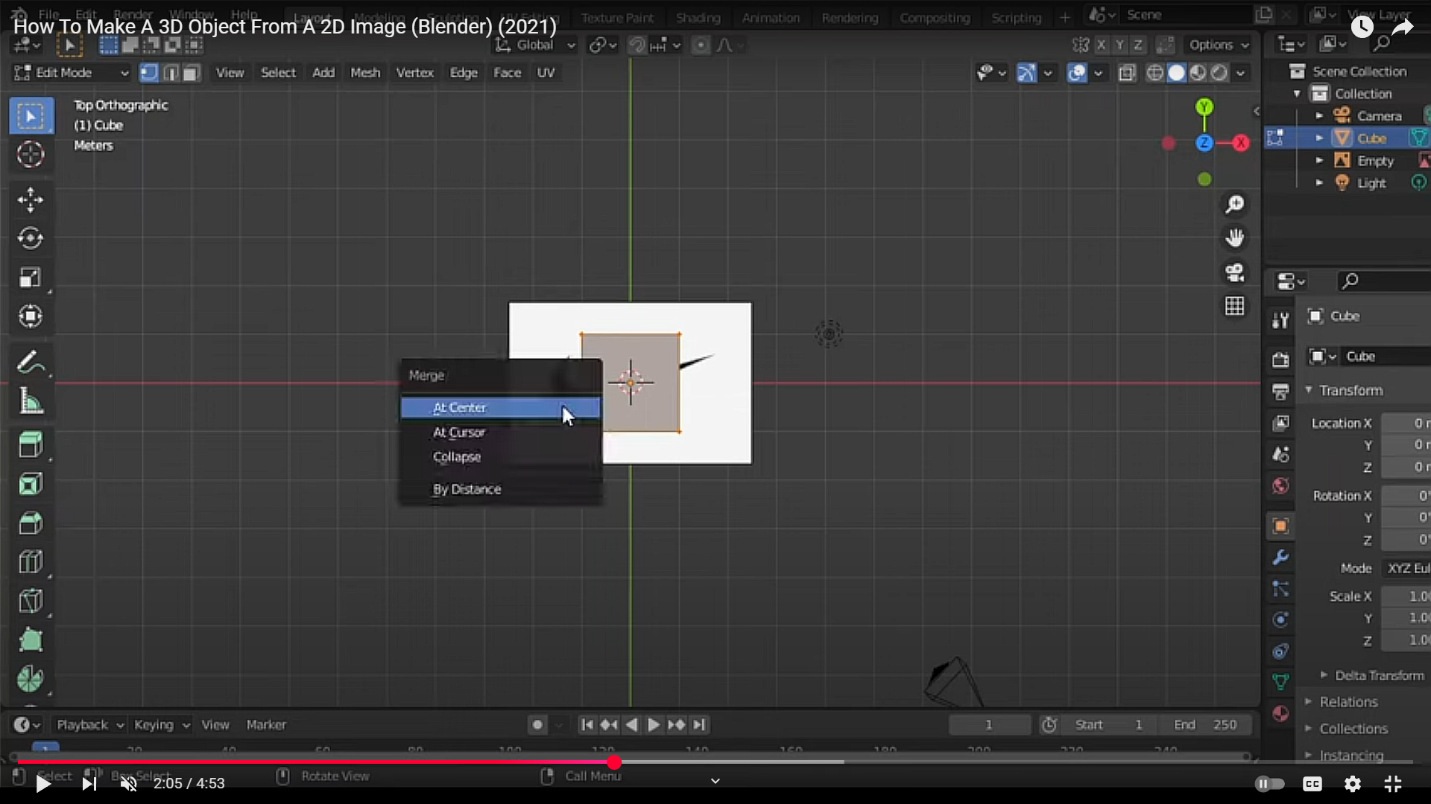

6-Making-a-3D-Object-from-a-2D-Image